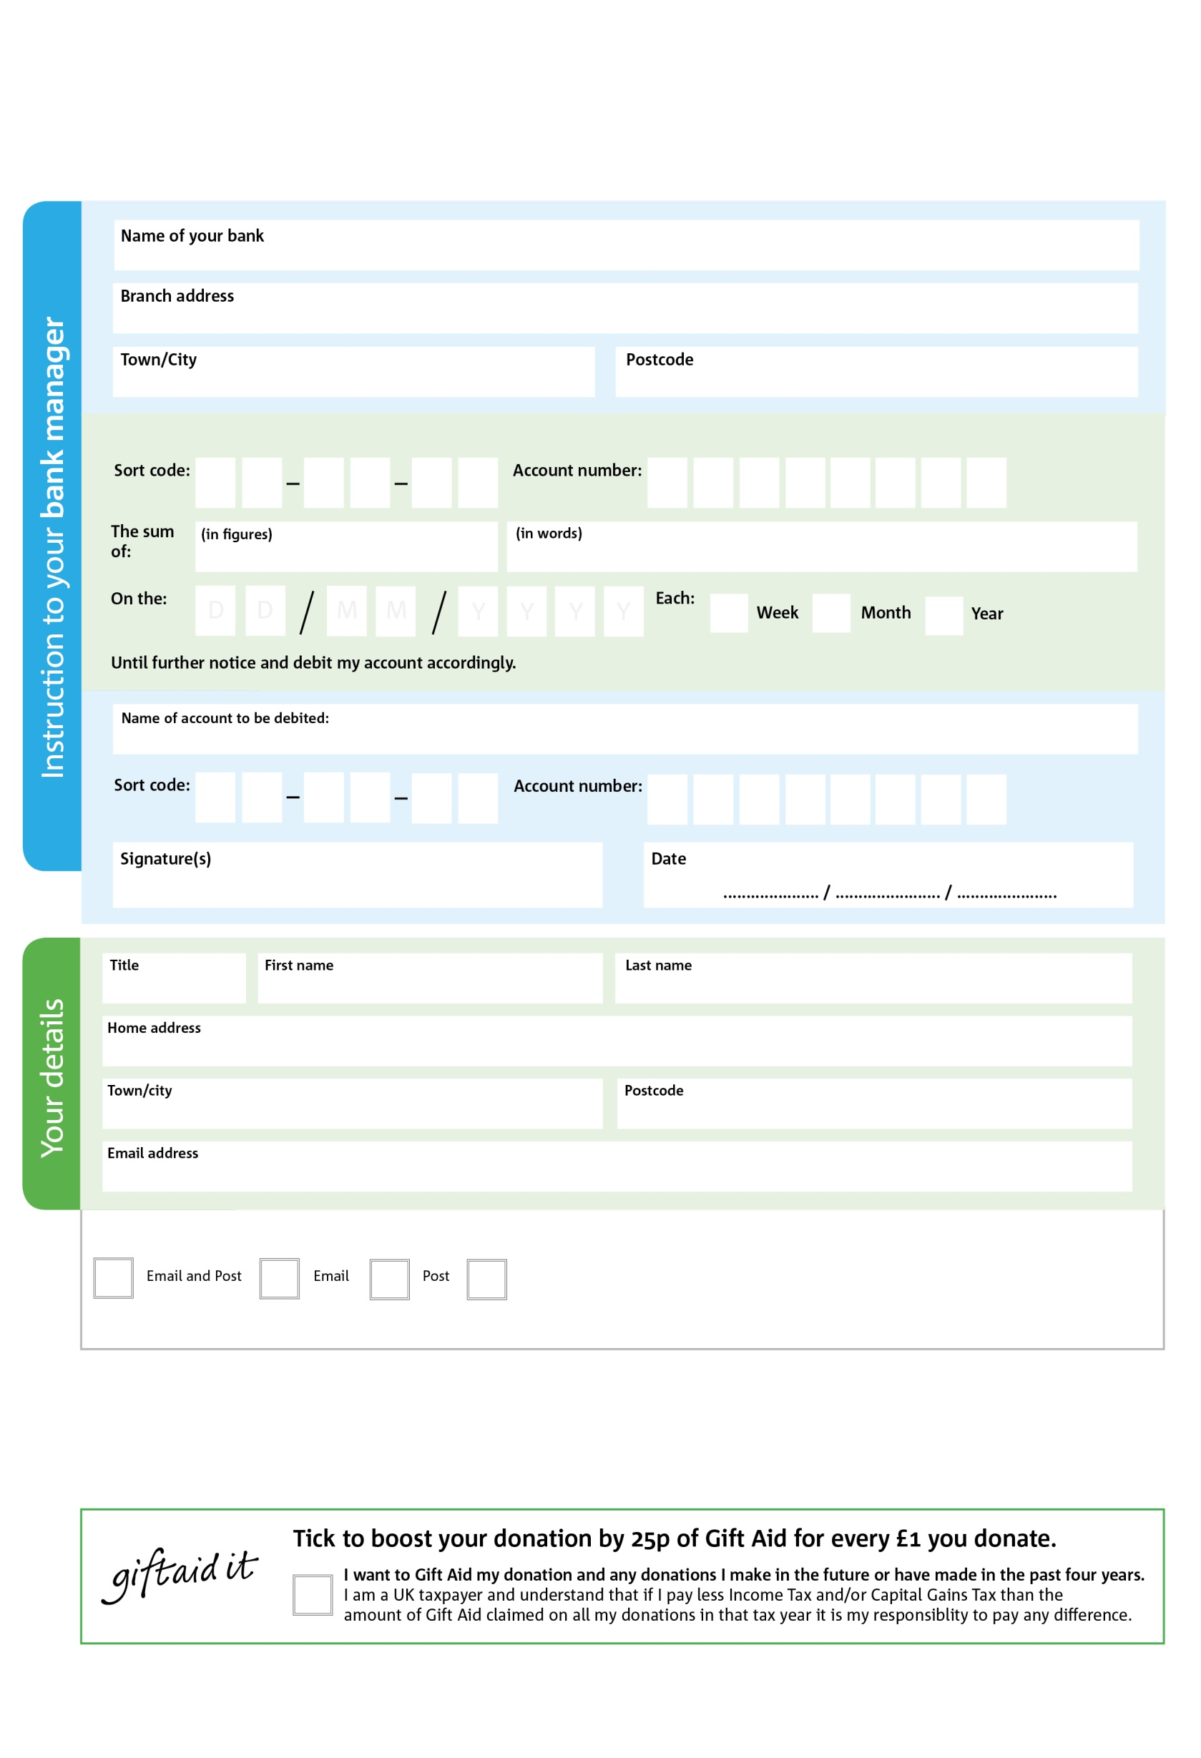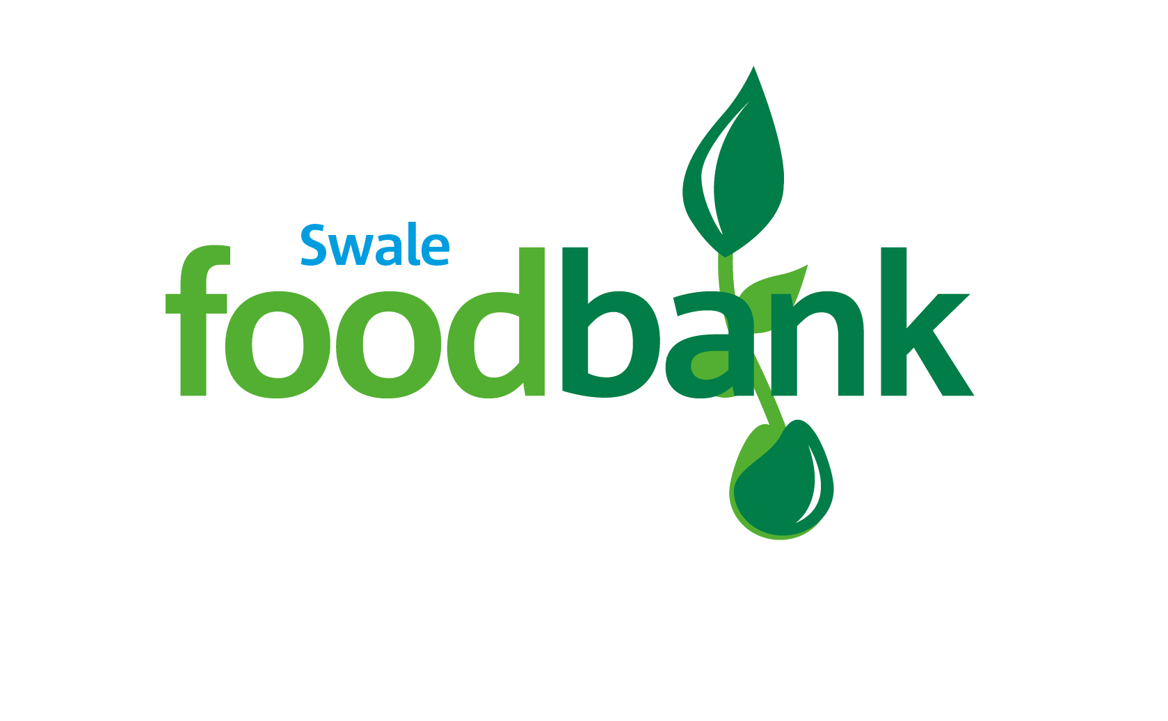

2To manage the administrative and planning duties involved

in the operation of Bognor Foodbank in accordance with The Trussell Trust franchise model

and to support the Manager, Deputy Manager (Wellbeing) and Stock Manager in the day to day

running of the Foodbank with concern for its operational efficiency and standards in

accordance with The Trussell Trust franchise model

Reg. Charity No: 1190373 | Reg. in England & WalesWales

22

2

POSTAL ADDRESS: Swale Foodbank, 95 East Street, Sittingbourne, Kent ME10 3PB

7

V

7

V

6

V

1

V

2

V

0

V

9

V

2

V

**Please pass this form onto the foodbank, using the foodbank’s address at the bottom, who will save a copy for their records.   
They will then send it onto your named bank or building society.**

5To manage the administrative and planning duties involved

in the operation of Bognor Foodbank in accordance with The Trussell Trust franchise model

and to support the Manager, Deputy Manager (Wellbeing) and Stock Manager in the day to day

running of the Foodbank with concern for its operational efficiency and standards in

accordance with The Trussell Trust franchise model

99

1

1

0

6X

We would love to keep you up to date with information about Swale Foodbank. Please tick your preference:

You can change your preferences any time by contacting us on 07486 370709 or emailing us at info@swale.foodbank.org.uk

I do not wish to receive future communications from Swale Foodbank

Please pay Swale Foodbank,

**Data protection**

*Swale Foodbank is committed to protecting your privacy and will process your personal data in accordance with current Data Protection legislation. Swale Foodbank collects information to keep in touch with you and supply you with information relating to our work. To unsubscribe from our newsletter, send a message to the email address above with the word unsubscribe in the subject line. A full data privacy statement for financial donors is available from the foodbank on request.’*

**Standing Order Mandate**

**swale.foodbank.org.uk**

You can change your preferences any time by contacting us on XXXXXXXXXXX or emailing us at XXXX@XXXXXXXXXX.foodbank.org.uk

I do not wish to receive future communications from XXXXXX Foodbank