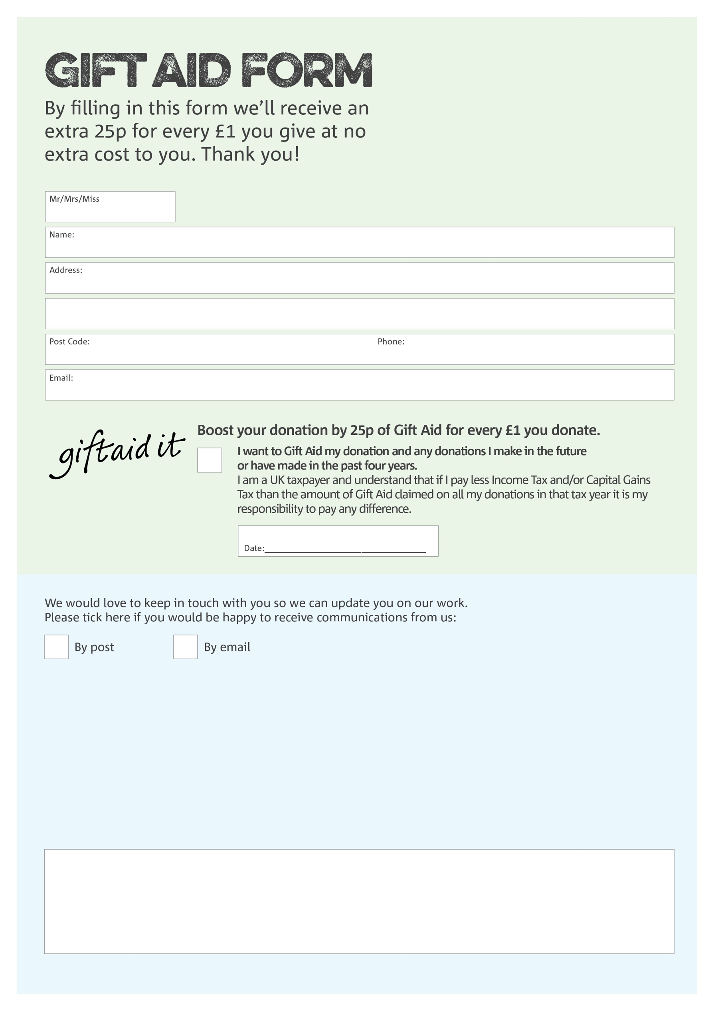

**Data protection**

XXXXX Foodbank is committed to protecting your privacy and will process your personal data in accordance with the Data Protection Act 1998. XXXXX Foodbank collects information to keep in touch with you and supply you with information relating to our work. XXXXX Foodbank will never sell or pass your details to anyone who isn’t directly working on our behalf.

You can change your preferences any time by contacting us on XXXXXXXXXX or emailing us at

xxxxxx@xxxxxx.foodbank.org.uk

We would love to know why you have chosen to donate to XXXXXX Foodbank. If you would like to share your motivation let us know below:

Charity Number XXXXXX. Registered in XXXXXXX