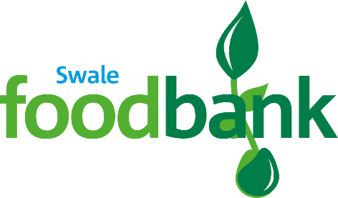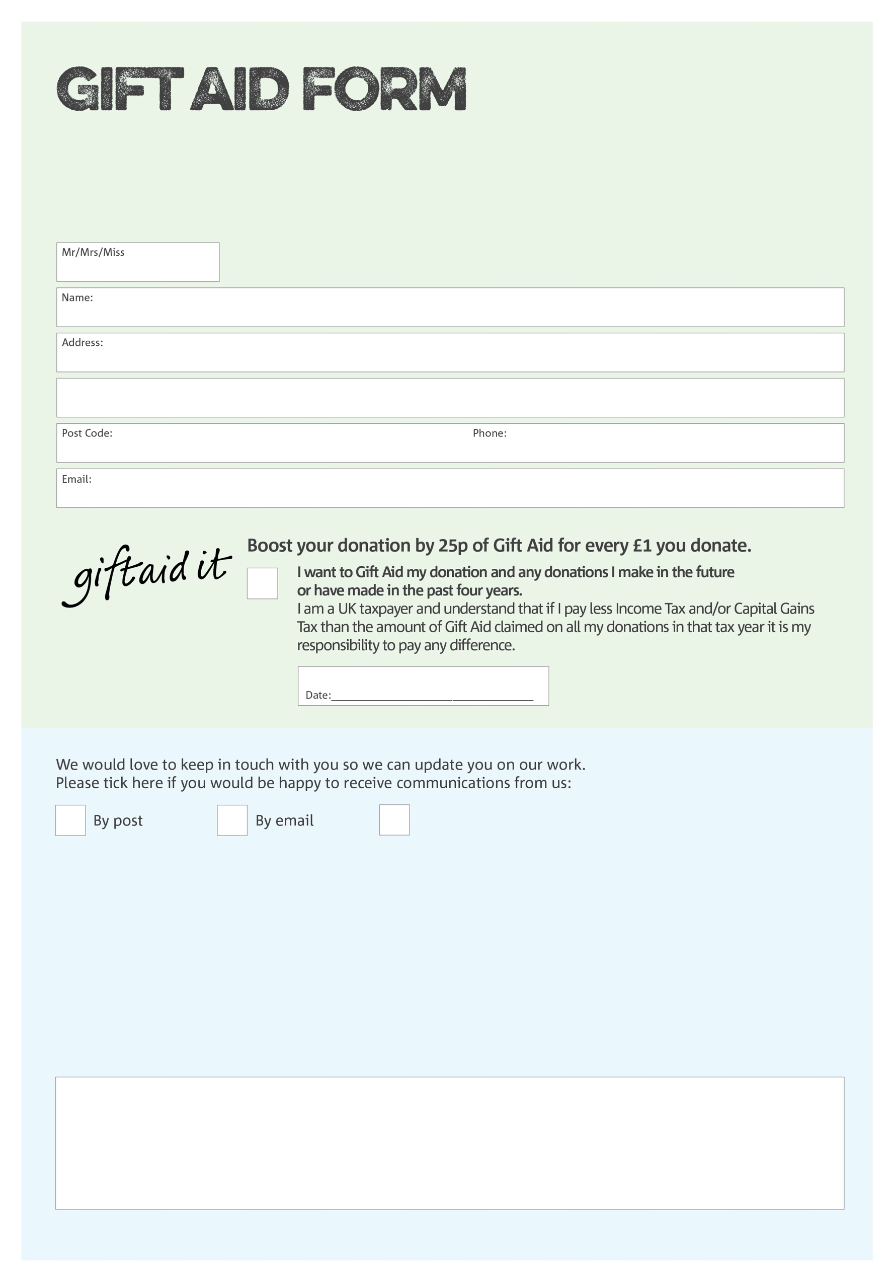

By filling in this form Swale Foodbank will receive an extra 25p for every £1 you give at no extra cost to you. Thank you!

**Data protection**

*'Swale Foodbank is committed to protecting your privacy and will process your personal data in accordance with current Data Protection legislation. Swale Foodbank collects information to keep in touch with you and supply you with information relating to our work. To unsubscribe from our newsletter, send a message to the email address above with the word unsubscribe in the subject line. A full data privacy statement for financial donors is available from the foodbank on request.’*

You can change your preferences any time by contacting us on 07486 370709 or emailing us at

info@swale.foodbank.org.uk

I do not wish to receive future communications from Swale Foodbank

We would love to know why you have chosen to donate to Swale Foodbank. If you would like to share your motivation let us know below:

Charity Number 1190373. Registered in England and Wales